**Expert in chartsjs to change charts of web application in laravel**

**The goal of job are: change the actual charts with the charts Chartsjs and add some options of charts. The changes regard the admin dashbard impostations and visulaizzation of charts in user pages**

**Pratically my web application have a charts builder page you show in user page. By the following page (chart&table, see image attached) it is possible select one of a list of charts. I want change these charts with all plugin Chartsjs with all options regard the charts**

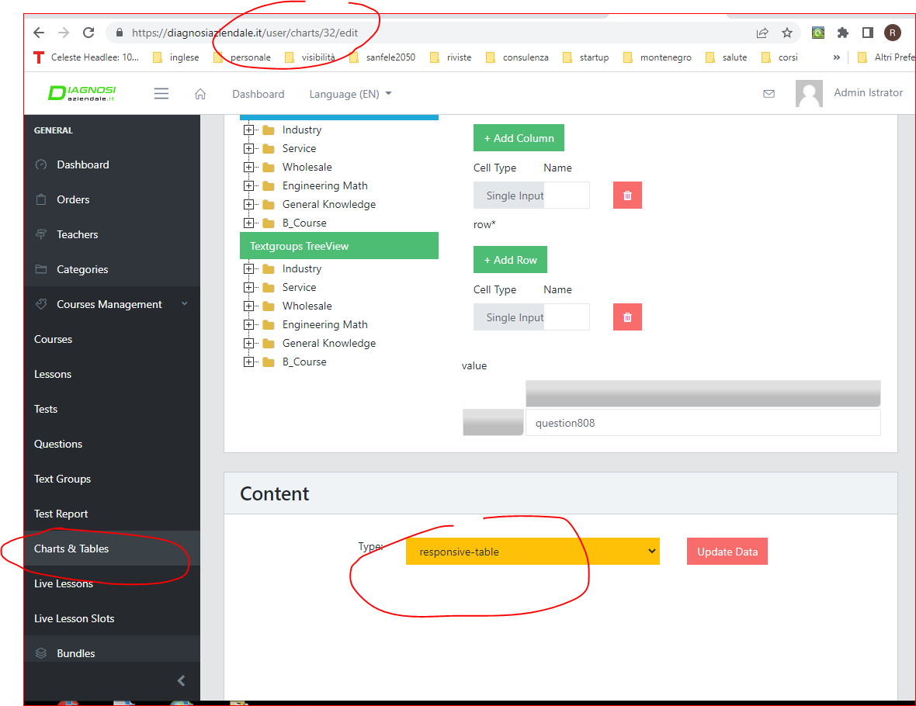

**Features:**

**- change** the actual **type of charts with all charts of chartjs; It is necessray change only the design, not the connections to the query builder because l already works. Pratically the charst in user must show the same value of actula charts.**

**- add some options regard the charts, so colors, dimention of charts and tables, type of value (number or %), position of series/legendf, alignment of balue, dimention and font. Pratically it must have the options similar to excel or configuration of chartsjs. All options must be saved in the database. In this way must be changed by edit. The following image is an example (wpdatatable) to understand what means options.** 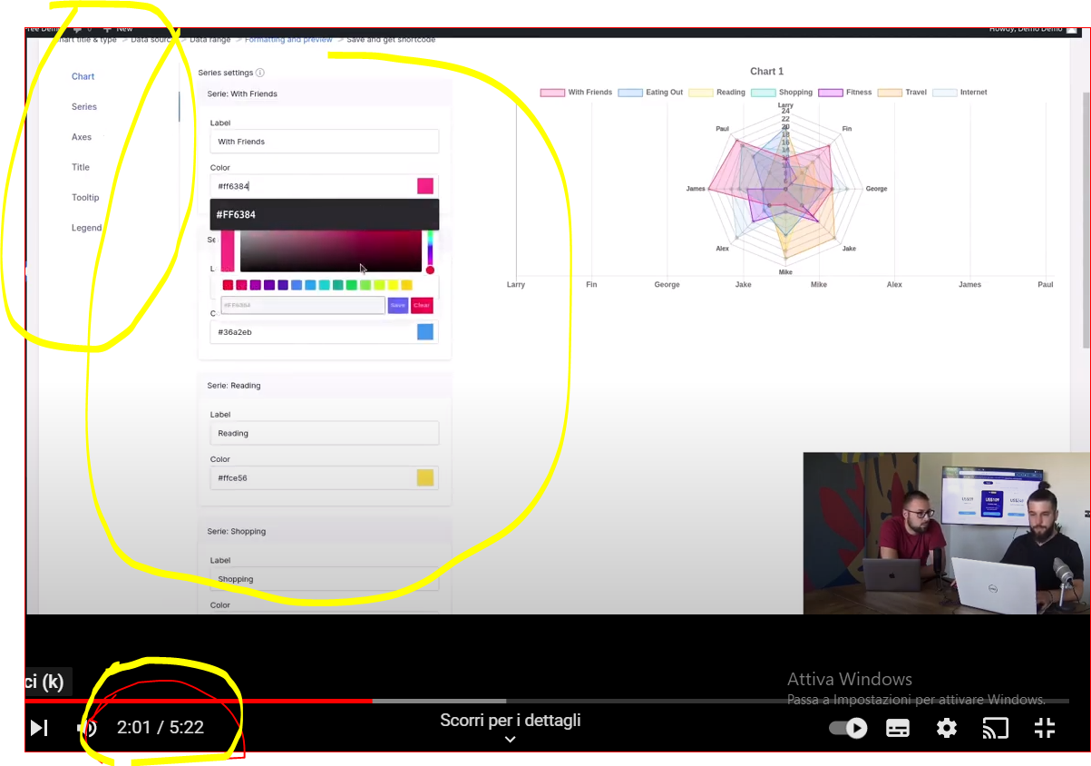

**Regard dimention: To show the charts in the report (user page) the software use a short code. Now the software don’t show the charts in automatic dimention. so It is necessary add also the option of dimention of charts to show correctly in the report because now don’t work good. It is essential ……now don’t work (see images). So it is necessary solve this problems by page charts &table**

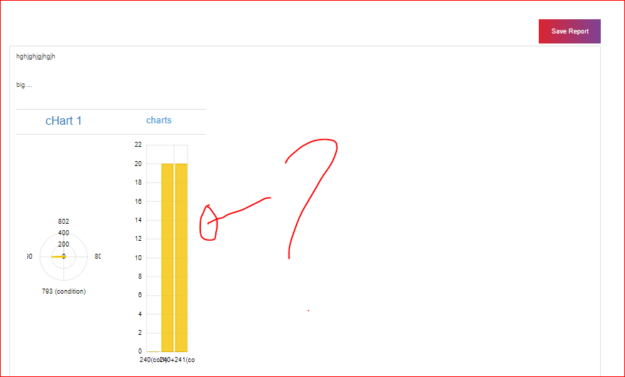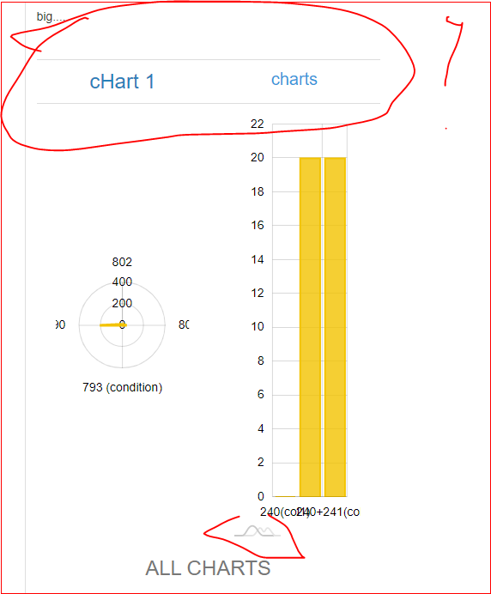

**- The options are necessary also for the actual table content (there are two type of table). So it is necessary that the adminisatrator can change so colors, dimention of charts and tables, type of value (number or %), position of series/legenf, alignamet of balue, dimention and font.**

**- Finally it is necessary add how content a not table and charts to use simple text or to add image altrenatively to a charts or table. Now it is possible only using a table how you see in the next image.**

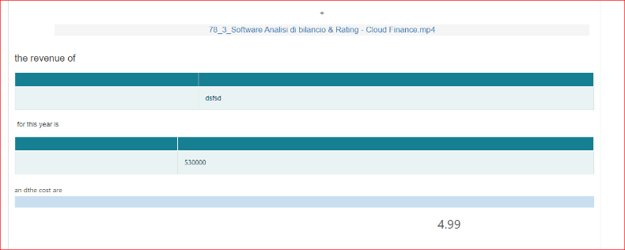

**but I want something similar to the following image**

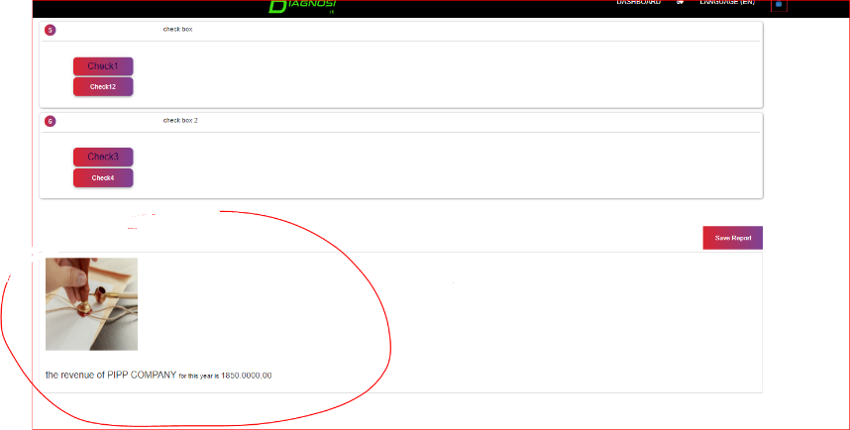

**I attach the type of chartsjs to add:**

[https://www.chartjs.org/docs/latest/samples/bar/horizontal.html](https://www.freelancer.com/users/l.php?url=https:%2F%2Fwww.chartjs.org%2Fdocs%2Flatest%2Fsamples%2Fbar%2Fhorizontal.html&sig=1551edb575ba5e4c9017f96cd757455594480e454e246c4be1abf4b8db5d2159)

[https://www.chartjs.org/docs/latest/samples/bar/stacked.html](https://www.freelancer.com/users/l.php?url=https:%2F%2Fwww.chartjs.org%2Fdocs%2Flatest%2Fsamples%2Fbar%2Fstacked.html&sig=e4c02c5408b7be9ce282c5330098b31744fee4faf91da425592cb8303184b030)

[https://www.chartjs.org/docs/latest/samples/bar/vertical.html](https://www.freelancer.com/users/l.php?url=https:%2F%2Fwww.chartjs.org%2Fdocs%2Flatest%2Fsamples%2Fbar%2Fvertical.html&sig=916ef1ab4c95348132c39ce6c885ea1ebb346628a4e6071fefc2bfb313d703de)

[https://www.chartjs.org/docs/latest/samples/line/line.html](https://www.freelancer.com/users/l.php?url=https:%2F%2Fwww.chartjs.org%2Fdocs%2Flatest%2Fsamples%2Fline%2Fline.html&sig=adc2ed659d3866b74620d7819cd58c080bf2178a28ad0a05e156c9951b3a0f18)

[https://www.chartjs.org/docs/latest/samples/line/point-styling.html](https://www.freelancer.com/users/l.php?url=https:%2F%2Fwww.chartjs.org%2Fdocs%2Flatest%2Fsamples%2Fline%2Fpoint-styling.html&sig=fdb9032f5cd7bb93fb4984bd33ebb5742599c6e6f1f45bd506101555a636ba09)

[https://www.chartjs.org/docs/latest/samples/other-charts/bubble.html](https://www.freelancer.com/users/l.php?url=https:%2F%2Fwww.chartjs.org%2Fdocs%2Flatest%2Fsamples%2Fother-charts%2Fbubble.html&sig=ef69db80791194b4fc772d8441372885fc6ff46d5e6548fbaf6f92aff1a9ddcb)

[https://www.chartjs.org/docs/latest/samples/other-charts/combo-bar-line.html](https://www.freelancer.com/users/l.php?url=https:%2F%2Fwww.chartjs.org%2Fdocs%2Flatest%2Fsamples%2Fother-charts%2Fcombo-bar-line.html&sig=c4b333be90f04ed3c763d52b50ca2d983594a26e510c4ee632851305668908bf)

[https://www.chartjs.org/docs/latest/samples/other-charts/doughnut.html](https://www.freelancer.com/users/l.php?url=https:%2F%2Fwww.chartjs.org%2Fdocs%2Flatest%2Fsamples%2Fother-charts%2Fdoughnut.html&sig=0af12adebf5397ede485695f13f3642cde7a602f18667311423d5b7c0dec7201)

[https://www.chartjs.org/docs/latest/samples/other-charts/multi-series-pie.html](https://www.freelancer.com/users/l.php?url=https:%2F%2Fwww.chartjs.org%2Fdocs%2Flatest%2Fsamples%2Fother-charts%2Fmulti-series-pie.html&sig=a0b8ecb3f6063e129380482bf43de69ccf6e9e8887e902a6292e0caa3fc1e143)

[https://www.chartjs.org/docs/latest/samples/other-charts/pie.html](https://www.freelancer.com/users/l.php?url=https:%2F%2Fwww.chartjs.org%2Fdocs%2Flatest%2Fsamples%2Fother-charts%2Fpie.html&sig=e0272f44594216388b10106efbc902940ca80139d95740bb9f575b7f0d1b7e82)

[https://www.chartjs.org/docs/latest/samples/other-charts/polar-area.html](https://www.freelancer.com/users/l.php?url=https:%2F%2Fwww.chartjs.org%2Fdocs%2Flatest%2Fsamples%2Fother-charts%2Fpolar-area.html&sig=0af178f321b4ae0db56b3593a708a5f876e70d542724023a32bae2d0f141d2bc)

[https://www.chartjs.org/docs/latest/samples/other-charts/radar.html](https://www.freelancer.com/users/l.php?url=https:%2F%2Fwww.chartjs.org%2Fdocs%2Flatest%2Fsamples%2Fother-charts%2Fradar.html&sig=a0d60e106070d8844b69eaa694dcc0c780adca8b7d3d04cd9d87934a9282c105)

[https://www.chartjs.org/docs/latest/samples/other-charts/scatter.html](https://www.freelancer.com/users/l.php?url=https:%2F%2Fwww.chartjs.org%2Fdocs%2Flatest%2Fsamples%2Fother-charts%2Fscatter.html&sig=a24954c554f3a3639631c5794961aa90b295c9c1baffb57c0d8a6f871eeec36f)

[https://www.chartjs.org/docs/latest/samples/area/radar.html](https://www.freelancer.com/users/l.php?url=https:%2F%2Fwww.chartjs.org%2Fdocs%2Flatest%2Fsamples%2Farea%2Fradar.html&sig=2f0cac2ca107ecc2b4f8dc76e509cfa5587b0de3d0e815144c0ffa69b5654658)

[https://www.chartjs.org/docs/latest/samples/area/line-stacked.html](https://www.freelancer.com/users/l.php?url=https:%2F%2Fwww.chartjs.org%2Fdocs%2Flatest%2Fsamples%2Farea%2Fline-stacked.html&sig=960da04a36bd8b70f275b85382845de7455474e7cc23cbfd91a8f72e0da807f3)

Conditions

- Max budget: 30$

- deadline 1-2 day

- I asign the job only if the developer demostrate experience in job with charts, so i can open the milestone only after demostrate that can do by a proof.

- I can open the milestone, but the developer must acept only after show me the first changes (so we avaid to pay fee to Freelancer)